Project Design Phase-II
Data Flow Diagram & User Stories

Project Name | Project - Real time River water quality monitoring and control system
Members | Abiyavincy D  Berlin K  Jemilda J  Kerin Shinu VS
Data Flow Diagram:

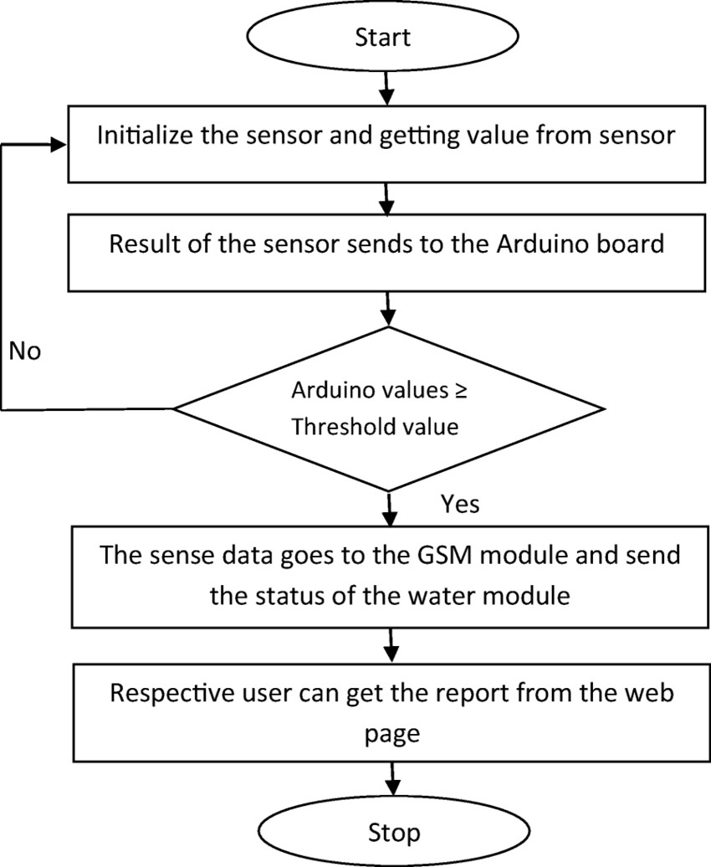

User Stories

User Type | Functional  Requirement (Epic) | User Story  Number | User Story / Task | Acceptance criteria | Priority | Release
Customer  (Mobile user) | Registration | USN-1 | As a user, I can register for the application by entering email , password, and confirming my password. | I can access my account/dashboard | High | Sprint-1
 |  | USN-2 | As a user, I will receive a confirmation email once I have registered for the application | I can receiva e confirmation email & click confirm | High | Sprint-2
 |  | USN-3 | As a user, I can register for the application through google | I can register & access the dashboard with google | High | Sprint-1
 |  | USN-4 | As a user, I can register for the application through Gmail | I can register througthe h mail. | Medium | Sprint-2
 | Login | USN-5 | As a user, I can log into the application by entering email, password & captcha | I can receive login credentials. | High | Sprint-1
 | Interface | USN-6 | As a user, the interface should be user-friendly manner | I can able to access easily. | Medium | Sprint-1
Customer (Web user) | dashboard | USN-7 | As a user, I can access the specific info(ph value, temp, humidity, quality). | I can able to know the quality of the water. | High | Sprint-1
Customer (input) | View manner | USN-8 | As a user, I can view data in visual representation manner(graph) | I can easily understand by visuals. | High | Sprint-1
 | Taste | USN-9 | As a user , I can able to view the quality(salty) of the water | I can easily know whether it is salty or not | High | Sprint-1
 | Colour visiblity | USN-10 | As a user , I can able predict the water colour | I can easily know the condition by colour | High | Sprint-1
Administrator | Risk tollerent | USN-11 | An administrator who Is handling the system should update and take care of the application. | Admin should monitor the records properly. | Medium | Sprint-2

